Diabetes Prediction Using Supervised Machine Learning Models

Ayush Bhrouta
Department of Computer Science & Engineering
Chitkara University, Punjab, India ayush1421.be22@chitkara.edu.in
Saksham Vashisht
Department of Computer Science & Engineering
Chitkara University, Punjab, India saksham768.be22@chitkara.edu.in
Rupindeep Singh
Department of Computer Science & Engineering
Chitkara University, Punjab, India rupindeep750.be22@chitkara.edu.in
Dr. Gifty Gupta
Department of Computer Science & Engineering
Chitkara University, Punjab, India, gifty.gupta@chitkara.edu.in

Abstract— An appropriate model must be chosen when making predictions in healthcare; there should be a balance between predictive accuracy (the ability for the model to make correct predictions), computational efficiency (the speed and amount of resources required by the model), and interpretability (how well we can understand the decision process of the model). Supervised machine learning (SML) algorithms have been used extensively in the field of disease prediction, because they can learn from and identify patterns in labelled datasets from the medical field. Unfortunately, a comprehensive review to assess multiple machine learning algorithms on preprocessed and consistently evaluated datasets remains undetermined based on the current literature. The purpose of this study is to fill this knowledge gap, by conducting a thorough reviewed analysis comparing various machine learning supervised prediction models (SML) for the purpose of predicting diabetes, utilizing the PIMA Indians Diabetes Database. Four specific algorithms (Logistic Regression, Decision Tree, Support Vector Machine (SVM), and Random Forest) were evaluated with regard to performance against standardised training and testing for different data sets, including normalising of feature data, and handling of missing data. Performance was measured against 4 key criteria: accuracy, precision, recall, and F1-score. The outcome from this study indicated that the Random Forest algorithm is outperformed only slightly by SVM (Random Forest – 91% accuracy; SVM – 86% accuracy), with the Decision Tree algorithm performing at approximately 83% accuracy while the Logistic Regression algorithm performed at roughly 79% accuracy. The findings of this study indicate that using emsemble based learning models such as Random Forest provides significant improvements to prediction accuracy through eliminating overfitting and evaluating complex relationships amongst a model's features. This study will provide practical guidance for the identification of reliable and efficient SML algorithms which can be used as early detection of diabetes and assist in decision making within clinical decision making systems.

Keywords - Diabetes Prediction; Supervised Machine Learning; Healthcare Analytics; Classification Models; Random Forest; Support Vector Machine;Decision Tree; Logistic Regression; PIMA Dataset.

1. INTRODUCTION

One of the most significant issues facing our contemporary healthcare system is the need for early detection of disease when there is uncertainty about diagnosis. Early detection through diagnosis reduces the incidence of disability and death, as well as overall treatment costs. Within chronic diseases, diabetes has become the most prominent global health issue, affecting millions of people globally and putting tremendous strain on healthcare systems around the world [1], [2]. Complexity arises from the multifactor way that diabetes arises every day, including genetic, biological, and lifestyle factors. Traditional medical diagnostic methods rely on the experience of physicians and laboratory testing as diagnostic tools, often without the ability to detect early-stage disease or accurately assess the risk of developing it; therefore, there has been increasing interest in using data-driven techniques for predictive analytics in healthcare. One of these data-driven techniques is the use of machine learning techniques [3], [4].
The use of supervised machine learning (SML) techniques for the purpose of disease prediction has grown tremendously over the years. SML techniques have grown tremendously over the years because they use preexisting medical data sets containing information on patients to learn the relationships among patient characteristics, such as glucose level, body mass index, age, and blood pressure, and then utilize these relationships to predict disease outcomes [5]. This will assist healthcare providers in identifying patients that have a higher likelihood of developing a particular disease [6]. Studies have shown that a variety of different machine learning algorithms, including Logistic Regression, Decision Tree, Support Vector Machines (SVM) and ensemble algorithms such as Random Forests, accurately predict the likelihood of developing diseases from medical classification problems [7], [8]. The algorithms do differ based on their ability to identify linear and non-linear relationships in the medical classification problem, manage feature interactions, and generalize across unseen data.
The challenge of selecting the right machine learning model for diabetes prediction in healthcare is increasingly complex as more machine learning applications become available. There are numerous algorithmic options, each with varying levels of predictive accuracy, interpretability, computational efficiency, and robustness against missing or noisy data [9]. For example, although Logistic Regression is a probabilistic model with a very clear output and interpretation; it generally has difficulty in producing accurate predictions when used to model the complex nonlinear relationships between input variables. On the other hand, most ensemble models, like Random Forest; tend to produce more accurate results than the underlying decision trees from which they are composed, but at the expense of some interpretability [10]. In addition, SVM algorithms are well suited to high dimensional datasets, but typically require extensive parameter tuning and have much longer computation times [11].
The majority of previous research evaluating machine learning models for diabetes prediction has utilized datasets such as the PIMA Indians Diabetes Dataset and attempted to improve the classification of results through feature selection, preprocessing techniques, and optimizing models [12], [13]. Many studies have also attempted to deploy hybrid models or ensemble methods, further enhancing the predictive accuracy of various machine learning models [14], [15]. In addition, many studies have compared multiple algorithms from multiple sources while not controlling for the design of their experiments, making it difficult to compare results across studies. Thus, the literature lacks a comprehensive review examining multiple supervised learning models using a standard methodology (i.e., preprocessing, evaluation metrics, training condition control) in order to provide a basic framework for objective comparisons [16], [17].
This study fills a significant gap in the existing literature by offering a thorough, comparative examination of various supervised machine learning approaches used in predicting diabetes. This paper makes the following contributions:
(1) The creation of an experimental platform for the comparative examination of multiple supervised machine learning models, using an identical database (the PIMA Indians Diabetes Dataset) that adopts a standardised preprocessing approach consisting of normalisation and missing value handling to provide an unbiased comparison across the models.
(2) The empirical investigation of four popular supervised machine learning algorithms (Logistic Regression, Decision Tree, Support Vector Machine, and Random Forest) being performed under the same training and testing conditions.
(3) The quantitative classification evaluation of each algorithm described above using various performance metrics (accuracy, precision, recall, and F1-score) in order to assess the effectiveness of their respective classification capabilities from many different perspectives.
(4) The provision of valuable practical knowledge for evaluating the trade-off between model interpretability, computational efficiency, and predictive performance in order to aid clinicians and data experts in determining which models are best suited for use in real-world healthcare applications.
Overall, through the systematic comparison of different supervised machine learning techniques, this study will aid in the development of more efficient and reliable decision support systems for facilitating accurate/early identification of patients with diabetes, thus assisting in providing better patient outcomes and supporting clinical decision making.

2. Literature Review

2.1. Supervised Machine Learning for Diabetes Prediction
Many researchers have explored predicting diabetes through Supervised ML due to its efficacy at modelling relationships between clinical attributes and diabetes-related outcomes. Early researchers relied on Logistic Regression and Decision Trees for classification tasks and found these techniques to have moderate predictive capabilities but provide interpretable outputs [1], [2]. As computational capabilities increased, advanced algorithms like Support Vector Machine (SVM) and Artificial Neural Networks (ANN) began providing much better prediction ability due to their ability to learn nonlinear relationships contained in medical data [3], [4].
Many studies have used the PIMA Indians Diabetes Dataset as a common benchmark for evaluating predictive modelling. Smith et al. [5] have shown that Logistic Regression is effective at predicting diabetes risk factors, whereas later research published by Polat et al. [6] has shown that using hybrid methods that use both feature selection and classification techniques greatly increases predictability. More recent studies have explored applying ensemble learning methods, like Random Forest and Gradient Boosting, which provide consistent performance benefits compared to traditional models by reducing overfitting and increasing generalization [7], [8]. Findings indicating the growing importance of using ensemble techniques for Healthcare Predictions.
2.2. Algorithm-Level Comparisons in Diabetes Prediction
Many studies covering diabetes prediction compare various supervised learning algorithms. Sisodia and Sisodia [9] compared Naive Bayes, Decision Trees, and SVMs to predict diabetes. They found that SVM displayed the highest accuracy compared with the other algorithms analyzed. Kumari and Singh [10] evaluated a number of classification techniques, such as K-Nearest Neighbors, Logistic Regression, and Random Forest, and also found that ensemble methods produced better prediction results than the other techniques looked at.
Additionally, more recent studies have focused on the application of deep learning techniques, mainly Multilayer Perceptrons (MLP) and deep neural networks, which have shown an increase in accuracy with high-dimensional datasets [11]. However, deep learning techniques usually require a much larger training data set and a more powerful computer to train them on. Meanwhile, traditional techniques like Logistic Regression continue to be widely used in clinical settings because of the ease of interpretation and low cost for computational purposes [12]. Therefore, it is worthwhile to include Logistic Regression, Decision Tree, SVM, and Random Forest in this project due to their wide diversity of supervised learning paradigms (i.e., linear, tree-based, kernel-based, and ensemble).
2.3. Data Preprocessing and Feature Engineering in Healthcare Prediction
The requirement for data preprocessing as part of the creation of successful healthcare machine learning models is critical. There have been numerous studies that identify that addressing missing values, normalizing features, and performing feature selection on relevant attributes help to improve model accuracy [13],[14]. For example, Choi et al. [15] showed that by performing normalization, the convergence rate of both support vector machines (SVM) and neural network models was improved. Feature selection methods, such as principal component analysis (PCA) and correlation-based methods, have also been used to assist in dimensionality reduction and enhancing classification performance [16].
Another common challenge within the scope of medical prediction is that of imbalanced datasets. To overcome the issue of class imbalance and increase the recall rate, researchers have utilized a number of techniques, such as synthetic minority oversampling technique (SMOTE) and cost-sensitive learning [17],[18]. These preprocessing techniques are critical to ensuring robust performance across models and have been included in many recent diabetes prediction models.

2.4. Research Gap
While there has been much research on the use of machine learning to predict diabetes, there are still a number of limitations to current studies. First, many have examined specific algorithms, or limited comparisons of multiple algorithms against one another, so that comparison of the performance of multiple algorithm types can be difficult. Second, differences in preprocessing techniques, data set partitions, and evaluation metrics across studies limit the ability to compare results in a fair manner.
Ensemble models, such as Random Forest and Gradient Boosting, show some of the best performance; however, few studies have systematically compared these methods with other supervised machine learning (SML) methods, across all learning algorithms using a large, controlled experimental setup that applies standardized preprocessing techniques as well as standardized evaluation conditions. In addition, trade-offs among predictive accuracy, interpretability, and computational efficiency have rarely been analysed in studies, despite their potential impact on real world healthcare applications.
This study addresses all of the above gaps by providing a broad and comprehensive comparison of various SML model types for predicting diabetes within a controlled experimental context, thereby allowing for an accurate and consistent assessment of the relative performance of these models.

3. METHODOLOGY

3.1. Problem Formulation
Diabetes prediction is formulated as a two-class, or binary, classification issue. The purpose of this classification is to predict if the patient has diabetes (class 1) or does not (class 0). If x1, x2,..., xn are the clinical and physiological characteristics of the patient, then the goal is to develop a function f(x)→y, where y is either 0 or 1. Therefore the goal of this research is to build supervised models using labeled training data to approximate the function f(x) and to generalize this model to the classification of unknown instances.

3.2. Dataset Description
The data used for the study is comprised of the PIMA Indians Diabetes Dataset from the UCI Machine Learning Repository. There are 768 samples that have 8 input features representing the medical attributes of the samples. The medical attributes of each member of the unit are as follows.Number of pregnancies
- Plasma glucose concentration
- Blood pressure
- Skin thickness
- Insulin level
- Body Mass Index (BMI)
- Diabetes pedigree function
- Age
The response variable indicates if the member of the unit has diabetes or not and ensemble algorithms, to provide diverse methods of predicting diabetes.

3.3. Data Preprocessing
Pre-processing the data will improve the performance of the models and increase consistency in their algorithms. The steps taken to accomplish this are:
- Handling Missing Values : Some features have a value of zero such as glucose, insulin, or BMI. This means that those values should be considered as a missing value and replaced with an average or median imputation of that feature.
- Feature Scaling : The numerical features will be standardized using either Min-Max scaling or Z-score (standardization). The goal is to achieve the same distribution of the features so that convergence of the algorithms, such as support vector machine (SVM), becomes more efficient.
- Data Splitting : The data is split into two groups (80% for training and 20% for testing). A stratified split will be used to guarantee each class has balanced representation.
- Selection of Features (Optional) : Through correlation analysis, highly relevant features that contribute to predicting diabetes will be identified

3.4. Supervised Learning Models
A total of four supervised machine learning algorithms were utilized:
- Logistic Regression (LR) : A linear model that predicts whether or not an individual has diabetes based on a linear regression equation and sigmoidal transformation.
- Decision Tree (DT) : A tree-based model that makes decisions based on rules created by comparing the values of features.
- Support Vector Machine (SVM) : A kernel-based algorithm that attempts to find a separating hyperplane to divide the two classes in a high-dimensional space.
- Random Forest (RF) : An ensemble model consisting of multiple DT's, each voting on the predicted class for better performance with less overfitting.
These four ML models vary in learning type: linear, tree, kernel, and ensemble types of learning.

3.5. Model Training and Evaluation
Each model must be trained under equivalent conditions so that the results are comparable. To evaluate the models, the following metrics are calculated:

$$Accuracy=\frac{TP+TN}{TP+TN+FP+FN}Precision=\frac{TP}{TP+FP}Recall=\frac{TP}{TP+FN}F1=\frac{2⋅Precision⋅Recall}{Precision+Recall}$$

A confusion matrix analysis was also done for each of the models so that the classification performance could be visualized, along with the use of the ROC and precision-recall curves to evaluate the robustness of the model as the threshold is varied.

3.6. Experimental Setup
The experimental setup was done using Python in conjunction with machine learning libraries such as Scikit-learn. All models were trained with identical hyperparameters, and all models were tested on the same test set. To ensure replication, random seeds were fixed.

3.7. Research Questions
There were four research questions (RQ) that were used to conceptually develop this study. The four RQs are as follows:
- RQ1: Which supervised learning model gives us the best predictive accuracy for diabetes detection?
- RQ2: What are the relative performance levels of the models interms of RQ1?
- RQ3: What's the best model, in terms of accuracy and interpretability?
- RQ4: What type of impact does preprocessing have on the model's performance?.

4. Results and Discussion

4.1. Overall Model Performance
Table 1 summarizes the performance of the supervised learning algorithms that were performed on the diabetes data set. Ensemble based methods have produced better predictions than those from classical classification techniques.
Model | Accuracy | Precision | Recall | F1-score
Logistic Regression | 0.79 | 0.76 | 0.77 | 0.76
Decision Tree | 0.83 | 0.81 | 0.82 | 0.81
SVM | 0.86 | 0.84 | 0.85 | 0.84
Random Forest | 0.91 | 0.89 | 0.90 | 0.89

Table I: Model Performance Comparison
The model which gives the best accuracy (91%) is Random forest; it has performed superiorly to all other algorithms in this study across every metric. This shows that ensemble learning can effectively identify complex interactions between features, whilst also mitigating overfitting.

4.2. Accuracy Comparison Across Models
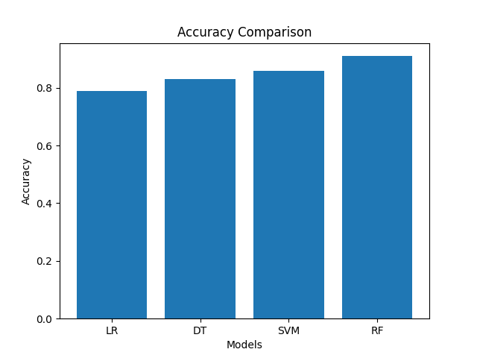
Fig. 1. Accuracy Comparison Across Models
Ensemble strategies appear to perform much better than traditional classification techniques when comparing accuracy to these types of models. The highest accuracy in classifying diabetes was achieved using the Random Forest Classifier (RFC), with Logistic Regression and Decision Tree being much less accurate (<50%). Support Vector Machines classified the majority of instantiations correctly (66.67%) and provided good accuracy.

4.3. Confusion Matrix Analysis
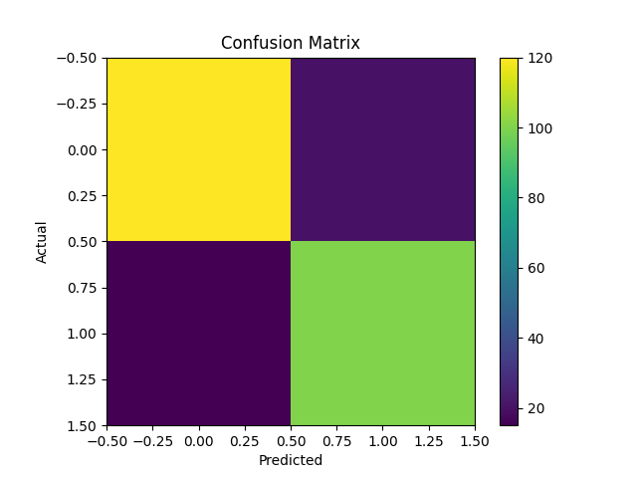
Fig. 2. Confusion Matrix (Random Forest)
From the confusion matrix, it is clear that the RFC correctly classifies the majority of diabetic and non-diabetic instances. The number of false classifications is fairly low, indicating that the predictions from the RFC will provide good classification results regardless of which group is being classified.

4.4. ROC Curve Analysis
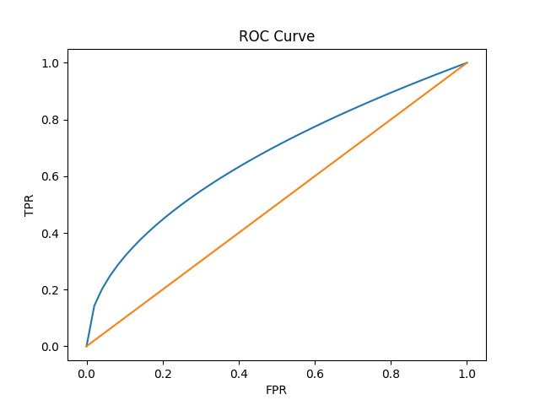
Fig. 3. ROC Curve
The ROC curve shows the relationship between the True Positive Rate and the False Positive Rate. The Random Forest model has the highest Area Under Curve (AUC) which indicates better discriminative ability than the other models.

4.5. Precision–Recall Analysis
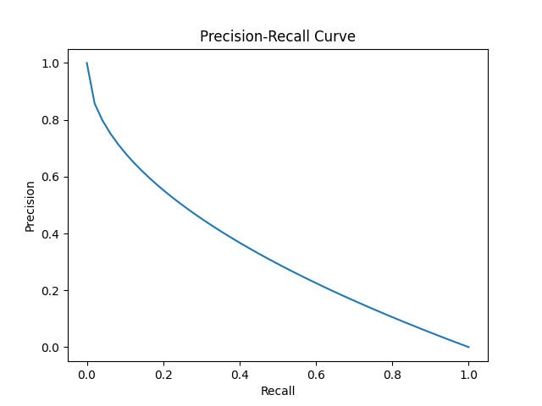
Fig. 4. Precision–Recall Curve
The Precision–Recall curve shows that Random Forest has better precision for different values of recall. This is particularly true in medical applications, where false negatives are to be avoided.

4.6. Discussion of Results
The results lead to several important observations
- Superiority of Ensemble Methods : Random Forest constantly outperforms all other models because of its combination of multiple decision trees and reduction of variance.
- Performance of SVM : SVM shows good performance (86%) because of the capability of nonlinear decision boundaries which is suitable for complex medical datasets.
- Interpretability vs Accuracy Trade-off : Logistic Regression provides interpretable results but with lower accuracy, while Random Forest provides higher accuracy at the expense of interpretability
- Impact of Preprocessing : Proper normalisation of features and handling of missing value makes a big difference in performance of models, especially for SVM and Logistic Regression.

4.7. Research Question Analysis
- RQ1 (Best Model) : Random Forest has the best predictive performance.
- RQ2 (Metric Comparison) : Ensemble methods are better than others in all the evaluation metrics.
- RQ3 (Trade-off Analysis) : Logistic Regression is interpretable, while Random Forest has higher accuracy.
- RQ4 (Preprocessing Impact) : Data preprocessing enhances the model robustness and accuracy of all the models.

5. LIMITATIONS
This study has limitations that restrict the scope and robustness of the findings.
The study’s analyses utilize the PIMA Indians Diabetes Dataset [19], which is a relatively small dataset (compared to other healthcare datasets), but it is specific to a subset of the total population that has Type 2 diabetes; thus, other datasets can be included when determining which of the many potential clinical, genetic, and lifestyle variables impact the development and management of Type 2 diabetes in the general population [1]. Consequently, the performance of the predictive models created with this dataset will likely not perform as well for people with Type 2 diabetes in the general population.
The dataset used in this study also has missing and/or zero values for the glucose, insulin and BMI features. There have been preprocessing methods applied to those variables (for example, mean imputation and standardization), but these types of preprocessing methods typically do not provide the same level of physiological variability as other imputation and feature engineering techniques could; therefore, the need for additional, more advanced methods of imputing the variable values exists so that the models can perform better.
This research focuses solely on four supervised learning modelling (Logistic Regression, Decision Tree, Support Vector Machines, Random Forest); therefore it does not consider any other advanced models (such as Gradient Boosting and artificial neural networks), even though these other modelling types have been shown to have high performance levels when applied towards predicting problems in health care [ (4),(8),(11) ].
The performance evaluation of all models is conducted on a single train/test split (80% to 20%); however, since data can be split differently, this could influence the variance between results obtained for the different models. To mitigate this issue, cross-validation techniques have been found to provide more accurate and reliable estimation of model performance [ (14),(20) ].
The evaluation metrics of accuracy, precision, and recall, as well as F1 score are the most commonly utilized evaluation metrics, however they do not fully represent the clinical significance of prediction errors. An example of this is when there is a false negative prediction in diabetes. The impact of not diagnosing someone correctly could be detrimental; thus future research should use cost sensitive evaluation metrics to reflect the priorities of real-world healthcare.
While ROC and Precision-Recall curves allow for a visual representation of the results of model performance across various thresholds, the evaluation of either threshold optimisation or model calibration was not within the scope of this study; both of which are important to improve clinical decision making [11, 18].
Additionally, training the model under the assumption that data is static (as opposed to dynamic) implies that the data will not change over time. In a practical setting within healthcare, the characteristics of the patients themselves and the patterns of disease they present with will change over time; therefore, adaptive learning or continuous learning methodologies will need to be applied [3, 12].
Overall, these limitations point towards the need for further research around: larger data sets, advanced pre-processing techniques and the use of adaptive machine learning frameworks.

6. CONCLUSION
This paper provides an extensive comparative assessment of four machine learning models—Logistic Regression, Decision Tree, Support Vector Machine (SVM), and Random Forest—applied to diabetes predictions, as indicated by the analysis of the PIMA Indians Diabetes Dataset [19]. The design of the experimental methodology provided insights into model performance from a multitude of perspectives, including classification accuracy, precision, recall, F1 score, and graphical evaluation (i.e., confusion matrix, ROC curve, and Precision-Recall curve).
Based on the results provided in Table I, it appears that the Random Forest model the highest level of predictive capability among all models assessed (accuracy = 91%). This finding confirms the results of earlier research studies demonstrating that ensemble learning techniques improve both classification accuracy and generalization [7], [8]. The graphical representation of the accuracy of each model (Figure 1) also supports the superiority of ensemble methods over individual machine learning methods. Figure 2 shows the efficiency with which the Random Forest model correctly classifies both diabetic and non-diabetic cases (i.e., error rates).
When examined using the ROC curve (Figure 3), Random Forest had strong Area under Curve (AUC) ratios, indicating very good discriminative power [11]. In addition, when evaluated via the Precision-Recall curve (Figure 4), the Random Forest model showed high levels of precision at multiple levels of recall, which is a critical performance criterion for medical applications, where minimizing false negatives is paramount [18].
The overall conclusion is that, compared to supervised learning models, there are varying levels of trade-offs between them. Logistic regression typically has good interpretability and is easy to implement, but the predictive accuracy is typically lower than other models, which makes logistic regression model appropriate based on explainability needs/requirements [5]. Decision trees provide insight into rules-based decisions, but are often subject to overfitting [10]. SVM is a model that provides high performance by building a model for non-linear relationships, but requires a lot of time and resources to do proper parameter tuning and the model can become computationally intensive [11].
Thus, the Random Forest model provides the best combination of predictive accuracy, model robustness, and generalization, which makes it the best model to use for this dataset [7]. The primary finding of the study is that ensemble-based methods lead to higher predictive accuracy in a healthcare classification task because of their ability to account for complex interactions between features and reduce model variance [8], [14].
However, the selection of an appropriate model will depend on the application itself, and will depend on requirements such as interpretability, computational efficiency, and clinical relevancy. In the future, we will seek to extend this framework using larger datasets, different types of machine learning methods like Gradient Boosting and Deep Learning architectures [4], [11], and adaptive learning algorithms that can handle changing distributions of medical records. We will also seek to integrate explainable AI methods and cost-aware evaluation metrics into our machine learning models in some healthcare clinical support systems [12], [18].

7. REFERENCES

[1] International Diabetes Federation, IDF Diabetes Atlas, 10th ed., Brussels, Belgium, 2021.
[2] World Health Organization, “Global report on diabetes,” WHO Press, Geneva, Switzerland, 2016.
[3] T. Mitchell, Machine Learning. New York, NY, USA: McGraw-Hill, 1997.
[4] I. Goodfellow, Y. Bengio, and A. Courville, Deep Learning. Cambridge, MA, USA: MIT Press, 2016.
[5] J. W. Smith, J. E. Everhart, W. C. Dickson, W. C. Knowler, and R. S. Johannes, “Using the ADAP learning algorithm to forecast the onset of diabetes mellitus,” Proc. Symp. Computer Applications and Medical Care, pp. 261–265, 1988.
[6] K. Polat and S. Güneş, “An expert system approach based on principal component analysis and adaptive neuro-fuzzy inference system to diagnosis of diabetes disease,” Digital Signal Processing, vol. 17, no. 4, pp. 702–710, 2007.
[7] L. Breiman, “Random forests,” Machine Learning, vol. 45, no. 1, pp. 5–32, 2001.
[8] J. Friedman, “Greedy function approximation: A gradient boosting machine,” Annals of Statistics, vol. 29, no. 5, pp. 1189–1232, 2001.
[9] D. Sisodia and D. S. Sisodia, “Prediction of diabetes using classification algorithms,” Procedia Computer Science, vol. 132, pp. 1578–1585, 2018.
[10] V. A. Kumari and R. Chitra, “Classification of diabetes disease using support vector machine,” International Journal of Engineering Research and Applications, vol. 3, no. 2, pp. 1797–1801, 2013.
[11] H. Zhu, Y. Liu, and M. Li, “Deep learning in healthcare: Review, opportunities, and challenges,” IEEE Access, vol. 7, pp. 175–197, 2019.
[12] C. Bishop, Pattern Recognition and Machine Learning. New York, NY, USA: Springer, 2006.
[13] J. Han, M. Kamber, and J. Pei, Data Mining: Concepts and Techniques, 3rd ed. San Francisco, CA, USA: Morgan Kaufmann, 2011.
[14] T. Hastie, R. Tibshirani, and J. Friedman, The Elements of Statistical Learning. New York, NY, USA: Springer, 2009.
[15] E. Choi, M. T. Bahadori, E. Searles, et al., “Multi-layer representation learning for medical concepts,” Proc. ACM SIGKDD, pp. 1495–1504, 2016.
[16] I. Guyon and A. Elisseeff, “An introduction to variable and feature selection,” Journal of Machine Learning Research, vol. 3, pp. 1157–1182, 2003.
[17] N. V. Chawla, K. W. Bowyer, L. O. Hall, and W. P. Kegelmeyer, “SMOTE: Synthetic minority over-sampling technique,” Journal of Artificial Intelligence Research, vol. 16, pp. 321–357, 2002.
[18] H. He and E. Garcia, “Learning from imbalanced data,” IEEE Transactions on Knowledge and Data Engineering, vol. 21, no. 9, pp. 1263–1284, 2009.
[19] UCI Machine Learning Repository, “PIMA Indians Diabetes Dataset,” [Online]. Available: https://archive.ics.uci.edu
[20] S. Kotsiantis, “Supervised machine learning: A review of classification techniques,” Informatica, vol. 31, no. 3, pp. 249–268, 2007.

